**Thomas LERCHUNDI**

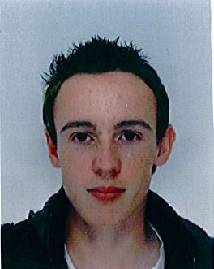(19 years old)

13 rue Beauséjour **PLACEMENT**

33610 CESTAS

FRANCE **ABROAD**

Tél : 06 45 29 15 05

lerchundi.thomas@gmail.com

**Formation**

… : 2nd year in University Institute of informatic

2013 : 1rst year University Diploma of Technology of informatic validated

2012 : **Bachelor of science** with engineering science option

**Computer knowledge:** Programming languages C, C++, C#, Java, J2EE, SQL, Bash, HTML5, CSS3, PHP, XML, Javascript. Control of operating systems Windows 7 and Linux.

Control of Word, SolidWorks (modelisation), Access, MySQL , SQL Server, Visual Studio, Eclipse, Geany.

**Knowledge**

**Professional experience**

2013 : **Sweeper**, Service cleens of the city of Bordeaux

2013 : **Order picker**, SCAMER (Bègles)

2008 : **Placement,** Radiology center of Cestas

**Center of interest**

**Cultural activities**: Travel :England, Morocco, Spain, Senegal

guitar practice for 11 years (4 years in a band), knowledge of music theory

**Sports** : Badminton, football